OSPF Area Types Lab

# CCNP Lab 3

## Axel Li

## 5 October 2018

# Purpose

The purpose of the lab was to review the different area types within OSPF and OSPFv3 that are commonly used in an OSPF configuration. We were tasked with configuring an OSPF network with each of the normal, stubby, totally stubby, and not-so-stubby area types, and confirm that the entire network was connected and functioning as intended with each respective area blocking and permitting specific LSAs through capturing packets and pinging between hosts and loopback interfaces.

# Background

In OSPF, each device maintains a link-state database of the network through routing updates, which can result in a heavy load in large networks. One solution is to implement multi-area OSPF, in which an autonomous system can be split into multiple areas to reduce overhead traffic on the network and shrink the database on each device. In particular scenarios, the load from OSPF can be reduced further by blocking unnecessary information in the area. For example, an area connected only to area 0 via a single router would not need any updates regarding other areas or external processes, as all traffic to outside the area would have to travel through that single router regardless of destination. There are five area variations within multi-area OSPF, with each type designed for a different situation and blocking different link state advertisements.

Normal areas are the default areas for multi-area OSPF. They utilize type 1-5 LSAs and each device within the area keeps track of all routing information, be it external, inter-area, or intra-area. Because of this, normal areas will work in all network topologies, though it will be the least efficient solution possible. All other types of OSPF areas can be considered modifications of normal areas which reduce the load most efficiently according to the specific network configuration and topology.

Stubby areas assume that the area is not connected to external autonomous systems, which commonly occurs within OSPF configurations. Based on this assumption, all traffic to external destinations must first enter another area within OSPF, meaning that there is no need for external routing information within the area. Because of this, stubby areas can block type 4 and 5 LSAs (which serve to communicate information from external processes).

Totally stubby areas act as stubby areas with the additional assertion that there is only one exit point to other areas. Since all traffic to outside the area must exit through that point, a default route would suffice for all traffic leaving the area and totally stubby areas block type 3 LSAs.

Not-so-stubby areas act similarly to stubby areas with the exception that redistribution of external routes is permitted within an area. NSSAs can be implemented in stub network areas that also connect to an external process. In order to work around the restriction that type 5 LSAs are not allowed, NSSA ASBRs generate type 7 LSAs that act as a substitute. NSSAs are common in actual OSPF implementations, as they have additional flexibility while maintaining the benefits of stubby area implementations.

Totally not-so-stubby areas have the same restrictions as not-so-stubby areas, but also presume that the area has one exit point. Essentially a crossover between totally stubby areas and not-so-stubby areas, totally not-so-stubby areas block type 3, 4, and 5 LSAs and use type 7 LSAs. Note that this type of OSPF area is not commonly used and was not implemented in this lab.

# Summary

Before physically configuring the devices, my partner and I planned out the topology, addressing and port scheme, and areas. We modified the configuration of a previous lab on multi-area OSPF, making a few adjustments to suit this lab such as attaching an additional external routing system and configuring each area to be of a different type. In the configuration itself, we enabled IPv6 routing and disabled switching (on the layer 3 switches), set IP addresses, input network commands, set router-IDs, and configured the OSPF area types on the devices.

After creating the configurations, we connected the cables between the devices and pasted the configurations we prepared into each device. To test the devices, we then input various show and ping commands such as show ip route to confirm that the network was set up and working as intended.

# Commands

The key commands used in this lab were:

area [area-id] stubby [no-summary] – configures the specified area to become a stubby area; the no-summary modifier makes the area totally stubby instead by also blocking type 3 LSAs

area [area-id] nssa – configures the specified area to become a NSSA

monitor session [session-number] source interface [interface-id] – configures the specified session to record all bidirectional traffic across the specified port

monitor session [session-number] destination interface [interface-id] - configures the specified session to send a copy of all traffic within the session through the specified port

show run – outputs the full configuration of the device

show ip route – displays all known IPv4 routes stored in the routing table

show ipv6 route – displays all known IPv6 routes stored in the routing table

show ip ospf database – outputs the link-state database of the ospf processes

show ipv6 ospf database – outputs the link-state database of the ospfv3 processes

# Tables and Diagrams

Network Topology with Port Addresses:

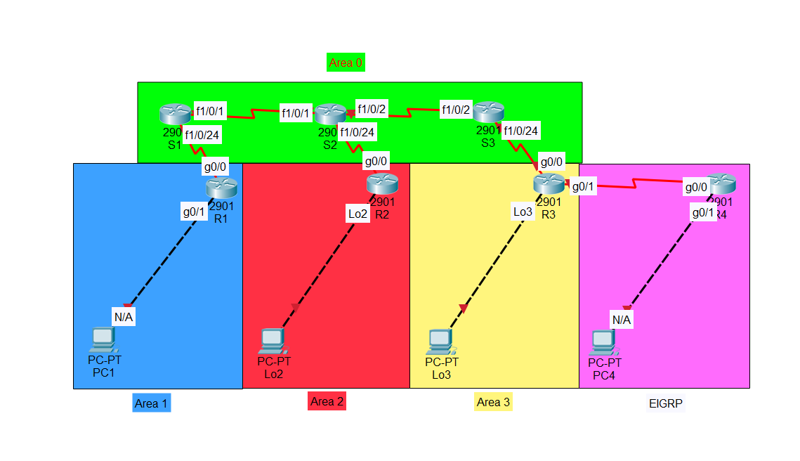

Network Topology with IPv4 Addresses:

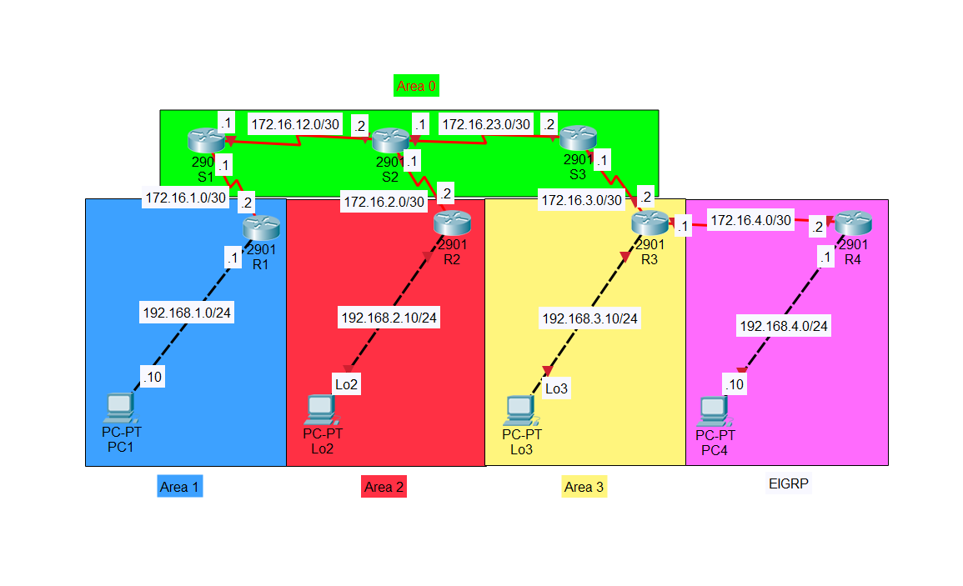

Network Topology with IPv6 Addresses:

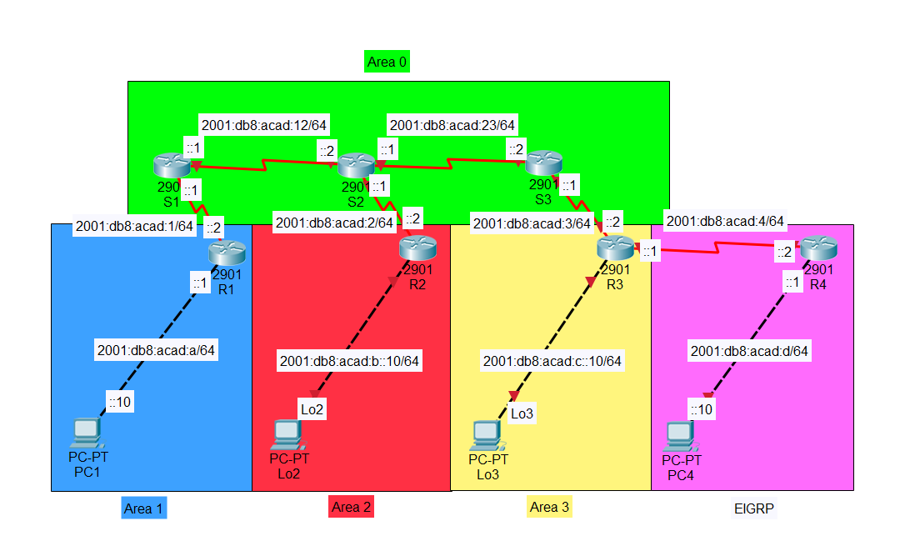

Device Links:

|  |  |  |  |  |  |
| --- | --- | --- | --- | --- | --- |
| Connection | Port | IPv4 Address | Subnet Mask | IPv6 Address | Area |
| S1 - S2 | f1/0/1 | 172.16.12.1 | 255.255.255.252 | 2001:db8:acad:12::1/64 | 0 |
| f1/0/1 | 172.16.12.2 | 2001:db8:acad:12::2/64 |
| S2 - S3 | f1/0/2 | 172.16.23.1 | 255.255.255.252 | 2001:db8:acad:23::1/64 |
| f1/0/2 | 172.16.23.2 | 2001:db8:acad:23::2/64 |
| S1 - R1 | f1/0/24 | 172.16.1.1 | 255.255.255.252 | 2001:db8:acad:1::1/64 | 1 |
| g0/0 | 172.16.1.2 | 2001:db8:acad:1::2/64 |
| R1 - H1 | g0/1 | 192.168.1.1 | 255.255.255.0 | 2001:db8:acad:a::1/64 |
| NA | 192.168.1.10 | 2001:db8:acad:a::10/64 |
| S2 - R2 | f1/0/24 | 172.16.2.1 | 255.255.255.252 | 2001:db8:acad:2::1/64 | 2 |
| g0/0 | 172.16.2.2 | 2001:db8:acad:2::2/64 |
| R2 - Loopback2 | lo2 | 192.168.2.10 | 255.255.255.0 | 2001:db8:acad:b::10/64 |
| S3 - R3 | f1/0/24 | 172.16.3.1 | 255.255.255.252 | 2001:db8:acad:3::1/64 | 3 |
| g0/0 | 172.16.3.2 | 2001:db8:acad:3::2/64 |
| R3 - Loopback3 | lo3 | 192.168.3.10 | 255.255.255.0 | 2001:db8:acad:c::10/64 |
| R3 - R4 | g0/1 | 172.16.4.1 | 255.255.255.252 | 2001:db8:acad:4::1/64 | [EIGRP] |
| g0/0 | 172.16.4.2 | 2001:db8:acad:4::2/64 |
| R4 - H4 | g0/1 | 192.168.4.1 | 255.255.255.0 | 2001:db8:acad:d::1/64 |
| N/A | 192.168.4.10 | 2001:db8:acad:d::10/64 |

Port Addressing:

|  |  |  |  |  |  |
| --- | --- | --- | --- | --- | --- |
| Device | Port | IPv4 Address | Subnet Mask | IPv6 Address | Area |
| Switch 1 | f1/0/1 | 172.16.12.1 | 255.255.255.252 | 2001:db8:acad:12::1/64 | 0 |
| f1/0/24 | 172.16.1.1 | 255.255.255.252 | 2001:db8:acad:1::1/64 | 1 |
| Switch 2 | f1/0/1 | 172.16.12.2 | 255.255.255.252 | 2001:db8:acad:12::2/64 | 0 |
| f1/0/2 | 172.16.23.1 | 255.255.255.252 | 2001:db8:acad:23::1/64 | 0 |
| f1/0/24 | 172.16.2.1 | 255.255.255.252 | 2001:db8:acad:2::1/64 | 2 |
| Switch 3 | f1/0/2 | 172.16.23.2 | 255.255.255.252 | 2001:db8:acad:23::2/64 | 0 |
| f1/0/24 | 172.16.3.1 | 255.255.255.252 | 2001:db8:acad:3::1/64 | 3 |
| Router 1 | g0/0 | 172.16.1.2 | 255.255.255.252 | 2001:db8:acad:1::2/64 | 1 |
| g0/1 | 192.168.1.1 | 255.255.255.0 | 2001:db8:acad:a::1/64 | 1 |
| Router 2 | g0/0 | 172.16.2.2 | 255.255.255.252 | 2001:db8:acad:2::2/64 | 2 |
| lo3 | 192.168.2.10 | 255.255.255.0 | 2001:db8:acad:b::10/64 | 2 |
| Router 3 | g0/0 | 172.16.3.2 | 255.255.255.252 | 2001:db8:acad:3::2/64 | 3 |
| lo3 | 192.168.3.10 | 255.255.255.0 | 2001:db8:acad:c::10/64 | 3 |
| g0/1 | 172.16.4.1 | 255.255.255.252 | 2001:db8:acad:4::1/64 | [EIGRP] |
| Router 4 | g0/0 | 172.16.4.2 | 255.255.255.252 | 2001:db8:acad:4::2/64 | [EIGRP] |
| g0/1 | 192.168.4.1 | 255.255.255.0 | 2001:db8:acad:d::1/64 | [EIGRP] |
| Host 1 | N/A | 192.168.1.10 | 255.255.255.0 | 2001:db8:acad:a::10/64 | N/A |
| Host 4 | NA | 192.168.4.10 | 255.255.255.0 | 2001:db8:acad:d::10/64 | NA |

OSPF and EIGRP Router-IDs of Devices:

|  |  |
| --- | --- |
| Device | OSPF Router-id |
| S1 | 1.1.1.1 |
| S2 | 2.2.2.2 |
| S3 | 3.3.3.3 |
| R1 | 10.10.10.10 |
| R2 | 20.20.20.20 |
| R3 | 30.30.30.30 |
| R4 | 40.40.40.40 |

Stubby Area Captured Packet:

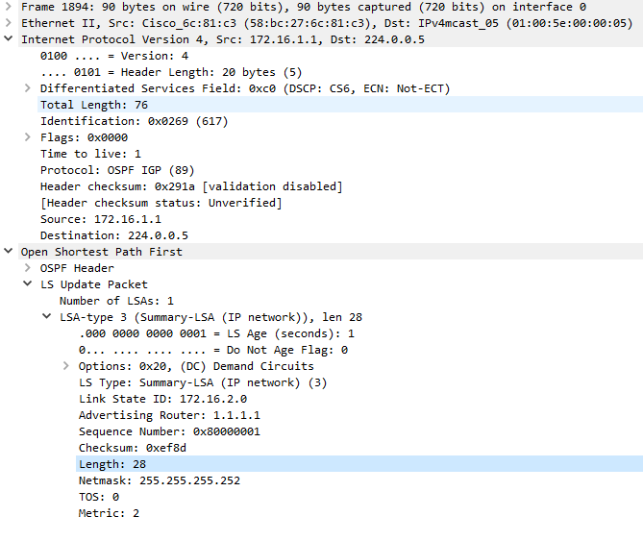

No type 4 and type 5 LSAs were captured within this area, indicating that this area is stubby.

Totally Stubby Area Captured Packet:

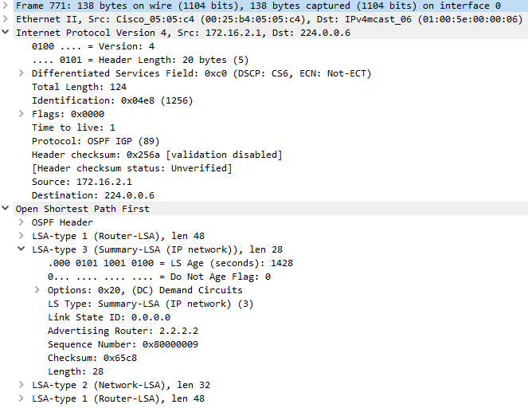

Only type 3 LSAs with specifically a default route were seen in this area; type 3, 4, and 5 LSAs were not present, meaning that this area is totally stubby.

NSSA Captured Packet:

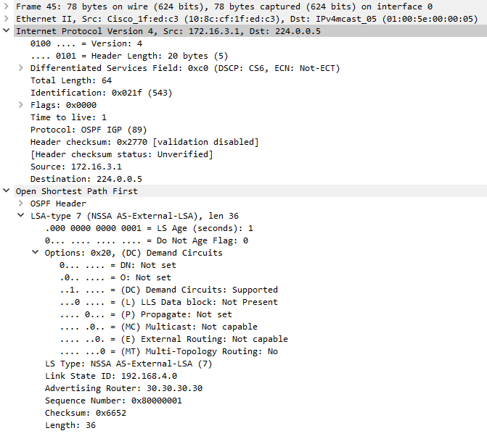

The existence of type 7 packets, along with the fact that no type 4 and type 5 LSA packets were seen within the area, proves that this area is not-so-stubby.

# Configurations

*Note that extraneous information may be omitted in the outputs below. *

**Switch 1:**

**S1#** show run

Building configuration...

Current configuration : 4302 bytes

Last configuration change at 00:18:12 UTC Mon Mar 1 1993

version 12.2

no service pad

service timestamps debug uptime

service timestamps log uptime

no service password-encryption

hostname S1

ip routing

ipv6 unicast-routing

interface FastEthernet1/0/1

no switchport

ip address 172.16.12.1 255.255.255.252

ipv6 address 2001:DB8:ACAD:12::1/64

ipv6 ospf 1 area 0

interface FastEthernet1/0/24

no switchport

ip address 172.16.1.1 255.255.255.252

ipv6 address 2001:DB8:ACAD:1::1/64

ipv6 ospf 1 area 1

router ospf 1

router-id 1.1.1.1

area 1 stub

network 172.16.1.0 0.0.0.3 area 1

network 172.16.12.0 0.0.0.3 area 0

ipv6 router ospf 1

router-id 1.1.1.1

area 1 stub

line con 0

line vty 0 4

login

line vty 5 15

login

monitor session 1 source interface Fa1/0/24

monitor session 1 destination interface Fa1/0/23

end

**S1#** show ip route

Gateway of last resort is not set

     172.16.0.0/16 is variably subnetted, 8 subnets, 2 masks

C        172.16.1.0/30 is directly connected, FastEthernet1/0/24

L        172.16.1.1/32 is directly connected, FastEthernet1/0/24

O IA     172.16.2.0/30 [110/2] via 172.16.12.2, 00:24:59, FastEthernet1/0/1

O IA     172.16.3.0/30 [110/3] via 172.16.12.2, 00:11:11, FastEthernet1/0/1

O E2     172.16.4.0/30 [110/20] via 172.16.12.2, 00:02:54, FastEthernet1/0/1

C        172.16.12.0/30 is directly connected, FastEthernet1/0/1

L        172.16.12.1/32 is directly connected, FastEthernet1/0/1

O        172.16.23.0/30 [110/2] via 172.16.12.2, 00:24:59, FastEthernet1/0/1

O     192.168.1.0/24 [110/2] via 172.16.1.2, 00:25:44, FastEthernet1/0/24

     192.168.2.0/32 is subnetted, 1 subnets

O IA     192.168.2.10 [110/3] via 172.16.12.2, 00:24:59, FastEthernet1/0/1

     192.168.3.0/32 is subnetted, 1 subnets

O IA     192.168.3.10 [110/4] via 172.16.12.2, 00:02:59, FastEthernet1/0/1

O E2  192.168.4.0/24 [110/20] via 172.16.12.2, 00:02:54, FastEthernet1/0/1

**S1#** show ipv6 route

C   2001:DB8:ACAD:1::/64 [0/0]

    via FastEthernet1/0/24, directly connected

L   2001:DB8:ACAD:1::1/128 [0/0]

    via FastEthernet1/0/24, receive

OI  2001:DB8:ACAD:2::/64 [110/2]

    via FE80::225:B4FF:FE05:5C1, FastEthernet1/0/1

OI  2001:DB8:ACAD:3::/64 [110/3]

    via FE80::225:B4FF:FE05:5C1, FastEthernet1/0/1

OE2 2001:DB8:ACAD:4::/64 [110/20]

    via FE80::225:B4FF:FE05:5C1, FastEthernet1/0/1

O   2001:DB8:ACAD:A::/64 [110/2]

    via FE80::4255:39FF:FED2:3690, FastEthernet1/0/24

OI  2001:DB8:ACAD:B::10/128 [110/2]

    via FE80::225:B4FF:FE05:5C1, FastEthernet1/0/1

OI  2001:DB8:ACAD:C::10/128 [110/3]

    via FE80::225:B4FF:FE05:5C1, FastEthernet1/0/1

OE2 2001:DB8:ACAD:D::/64 [110/20]

    via FE80::225:B4FF:FE05:5C1, FastEthernet1/0/1

C   2001:DB8:ACAD:12::/64 [0/0]

    via FastEthernet1/0/1, directly connected

L   2001:DB8:ACAD:12::1/128 [0/0]

    via FastEthernet1/0/1, receive

O   2001:DB8:ACAD:23::/64 [110/2]

    via FE80::225:B4FF:FE05:5C1, FastEthernet1/0/1

L   FF00::/8 [0/0]

    via Null0, receive

**S1#** show ip ospf database

           OSPF Router with ID (1.1.1.1) (Process ID 1)

               Router Link States (Area 0)

Link ID         ADV Router Age         Seq# Checksum Link count

1.1.1.1         1.1.1.1 1973        0x80000004 0x002D65 1

2.2.2.2         2.2.2.2 175         0x80000007 0x00E1E9 2

3.3.3.3         3.3.3.3 1324        0x80000006 0x0097CF 1

               Net Link States (Area 0)

Link ID         ADV Router Age         Seq# Checksum

172.16.12.2     2.2.2.2 175         0x80000003 0x00A5B6

172.16.23.2     3.3.3.3 49          0x80000003 0x0062E2

               Summary Net Link States (Area 0)

Link ID         ADV Router Age         Seq# Checksum

172.16.1.0      1.1.1.1 214         0x80000003 0x00CEAC

172.16.2.0      2.2.2.2 175         0x80000003 0x00A5D0

172.16.3.0      3.3.3.3 1324        0x80000002 0x007EF3

192.168.1.0     1.1.1.1 214         0x80000003 0x00BE0C

192.168.2.10    2.2.2.2 175         0x80000003 0x00318A

192.168.3.10    3.3.3.3 813         0x80000002 0x000AAD

               Router Link States (Area 1)

Link ID         ADV Router Age         Seq# Checksum Link count

1.1.1.1         1.1.1.1 214         0x80000006 0x005454 1

10.10.10.10     10.10.10.10 1071        0x80000008 0x00BB27 2

               Net Link States (Area 1)

Link ID         ADV Router Age         Seq# Checksum

172.16.1.2      10.10.10.10 1071        0x80000003 0x005DCB

               Summary Net Link States (Area 1)

Link ID         ADV Router Age         Seq# Checksum

0.0.0.0         1.1.1.1 214         0x80000003 0x008FA8

172.16.2.0      1.1.1.1 1973        0x80000002 0x00ED8E

172.16.3.0      1.1.1.1 1212        0x80000002 0x00EC8D

172.16.12.0     1.1.1.1 214         0x80000003 0x0073FE

172.16.23.0     1.1.1.1 1973        0x80000002 0x000661

192.168.2.10    1.1.1.1 1973        0x80000002 0x007948

192.168.3.10    1.1.1.1 708         0x80000002 0x007847

               Type-5 AS External Link States

Link ID         ADV Router Age         Seq# Checksum Tag

172.16.4.0      3.3.3.3 813         0x80000002 0x00ABB3 0

192.168.4.0     3.3.3.3 813         0x80000002 0x00911E 0

**S1#** show ipv6 ospf database

           OSPFv3 Router with ID (1.1.1.1) (Process ID 1)

               Router Link States (Area 0)

ADV Router       Age Seq#       Fragment ID Link count Bits

1.1.1.1         197 0x80000005  0 1 B

2.2.2.2         241 0x80000006  0 2 B

3.3.3.3         1368 0x80000006  0 1 B E

               Net Link States (Area 0)

ADV Router       Age Seq#       Link ID Rtr count

2.2.2.2         241 0x80000003  1019 2

3.3.3.3         137 0x80000003  1020 2

               Inter Area Prefix Link States (Area 0)

ADV Router       Age Seq#      Prefix

1.1.1.1         197 0x80000003  2001:DB8:ACAD:A::/64

1.1.1.1         197 0x80000003  2001:DB8:ACAD:1::/64

2.2.2.2         241 0x80000003  2001:DB8:ACAD:B::10/128

2.2.2.2         241 0x80000003  2001:DB8:ACAD:2::/64

3.3.3.3         1368 0x80000002  2001:DB8:ACAD:C::10/128

3.3.3.3         1368 0x80000002  2001:DB8:ACAD:3::/64

               Link (Type-8) Link States (Area 0)

ADV Router       Age Seq#       Link ID Interface

1.1.1.1         197 0x80000004  1019 Fa1/0/1

2.2.2.2         241 0x80000004  1019 Fa1/0/1

               Intra Area Prefix Link States (Area 0)

ADV Router       Age Seq#       Link ID Ref-lstype Ref-LSID

2.2.2.2         241 0x80000003  1043456 0x2002 1019

3.3.3.3         137 0x80000003  1044480 0x2002 1020

               Router Link States (Area 1)

ADV Router       Age Seq#       Fragment ID Link count Bits

1.1.1.1         197 0x80000005  0 1 B

10.10.10.10     1092 0x80000004  0 1 None

               Net Link States (Area 1)

ADV Router       Age Seq#       Link ID Rtr count

10.10.10.10     1092 0x80000003  4 2

               Inter Area Prefix Link States (Area 1)

ADV Router       Age Seq#      Prefix

1.1.1.1         197 0x80000003  ::/0

1.1.1.1         197 0x80000003  2001:DB8:ACAD:12::/64

1.1.1.1         197 0x80000003  2001:DB8:ACAD:23::/64

1.1.1.1         197 0x80000003  2001:DB8:ACAD:2::/64

1.1.1.1         197 0x80000003  2001:DB8:ACAD:B::10/128

1.1.1.1         1226 0x80000002  2001:DB8:ACAD:C::10/128

1.1.1.1         1226 0x80000002  2001:DB8:ACAD:3::/64

               Link (Type-8) Link States (Area 1)

ADV Router       Age Seq#       Link ID Interface

1.1.1.1         1226 0x80000004  1042 Fa1/0/24

10.10.10.10     1092 0x80000007  4 Fa1/0/24

               Intra Area Prefix Link States (Area 1)

ADV Router       Age Seq#       Link ID Ref-lstype Ref-LSID

10.10.10.10     1092 0x80000007  0 0x2001 0

10.10.10.10     1092 0x80000003  4096 0x2002 4

               Type-5 AS External Link States

ADV Router       Age Seq#      Prefix

3.3.3.3         1368 0x80000002  2001:DB8:ACAD:4::/64

3.3.3.3         1368 0x80000002  2001:DB8:ACAD:D::/64

**Switch 2:**

**S2#** show run

Building configuration...

Current configuration : 2758 bytes

Last configuration change at 00:23:27 UTC Mon Mar 1 1993

version 12.2

no service pad

service timestamps debug datetime msec

service timestamps log datetime msec

no service password-encryption

hostname S2

ip routing

ipv6 unicast-routing

interface FastEthernet1/0/1

no switchport

ip address 172.16.12.2 255.255.255.252

ipv6 address 2001:DB8:ACAD:12::2/64

ipv6 ospf 1 area 0

interface FastEthernet1/0/2

no switchport

ip address 172.16.23.1 255.255.255.252

ipv6 address 2001:DB8:ACAD:23::1/64

ipv6 ospf 1 area 0

interface FastEthernet1/0/24

no switchport

ip address 172.16.2.1 255.255.255.252

ipv6 address 2001:DB8:ACAD:2::1/64

ipv6 ospf 1 area 2

router ospf 1

router-id 2.2.2.2

area 2 stub no-summary

network 172.16.2.0 0.0.0.3 area 2

network 172.16.12.0 0.0.0.3 area 0

network 172.16.23.0 0.0.0.3 area 0

ipv6 router ospf 1

router-id 2.2.2.2

area 2 stub no-summary

line con 0

line vty 5 15

monitor session 1 source interface Fa1/0/24

monitor session 1 destination interface Fa1/0/23

end

**S2#** show ip route

Gateway of last resort is not set

     172.16.0.0/16 is variably subnetted, 9 subnets, 2 masks

O IA     172.16.1.0/30 [110/2] via 172.16.12.1, 00:44:54, FastEthernet1/0/1

C        172.16.2.0/30 is directly connected, FastEthernet1/0/24

L        172.16.2.1/32 is directly connected, FastEthernet1/0/24

O IA     172.16.3.0/30 [110/2] via 172.16.23.2, 00:31:06, FastEthernet1/0/2

O E2     172.16.4.0/30 [110/20] via 172.16.23.2, 00:22:49, FastEthernet1/0/2

C        172.16.12.0/30 is directly connected, FastEthernet1/0/1

L        172.16.12.2/32 is directly connected, FastEthernet1/0/1

C        172.16.23.0/30 is directly connected, FastEthernet1/0/2

L        172.16.23.1/32 is directly connected, FastEthernet1/0/2

O IA  192.168.1.0/24 [110/3] via 172.16.12.1, 00:44:54, FastEthernet1/0/1

     192.168.2.0/32 is subnetted, 1 subnets

O        192.168.2.10 [110/2] via 172.16.2.2, 00:46:02, FastEthernet1/0/24

     192.168.3.0/32 is subnetted, 1 subnets

O IA     192.168.3.10 [110/3] via 172.16.23.2, 00:22:54, FastEthernet1/0/2

O E2  192.168.4.0/24 [110/20] via 172.16.23.2, 00:22:49, FastEthernet1/0/2

**S2#** show ipv6 route

OI  2001:DB8:ACAD:1::/64 [110/2]

    via FE80::5ABC:27FF:FE6C:81C1, FastEthernet1/0/1

C   2001:DB8:ACAD:2::/64 [0/0]

    via FastEthernet1/0/24, directly connected

L   2001:DB8:ACAD:2::1/128 [0/0]

    via FastEthernet1/0/24, receive

OI  2001:DB8:ACAD:3::/64 [110/2]

    via FE80::128C:CFFF:FE1F:EDC1, FastEthernet1/0/2

OE2 2001:DB8:ACAD:4::/64 [110/20]

    via FE80::128C:CFFF:FE1F:EDC1, FastEthernet1/0/2

OI  2001:DB8:ACAD:A::/64 [110/3]

    via FE80::5ABC:27FF:FE6C:81C1, FastEthernet1/0/1

O   2001:DB8:ACAD:B::10/128 [110/1]

    via FE80::32E4:DBFF:FE67:1778, FastEthernet1/0/24

OI  2001:DB8:ACAD:C::10/128 [110/2]

    via FE80::128C:CFFF:FE1F:EDC1, FastEthernet1/0/2

OE2 2001:DB8:ACAD:D::/64 [110/20]

    via FE80::128C:CFFF:FE1F:EDC1, FastEthernet1/0/2

C   2001:DB8:ACAD:12::/64 [0/0]

    via FastEthernet1/0/1, directly connected

L   2001:DB8:ACAD:12::2/128 [0/0]

    via FastEthernet1/0/1, receive

C   2001:DB8:ACAD:23::/64 [0/0]

    via FastEthernet1/0/2, directly connected

L   2001:DB8:ACAD:23::1/128 [0/0]

    via FastEthernet1/0/2, receive

L   FF00::/8 [0/0]

    via Null0, receive

**S2#** show ip ospf database

           OSPF Router with ID (2.2.2.2) (Process ID 1)

               Router Link States (Area 0)

Link ID         ADV Router Age         Seq# Checksum Link count

1.1.1.1         1.1.1.1 1893        0x80000004 0x002D65 1

2.2.2.2         2.2.2.2 92          0x80000007 0x00E1E9 2

3.3.3.3         3.3.3.3 1241        0x80000006 0x0097CF 1

               Net Link States (Area 0)

Link ID         ADV Router Age         Seq# Checksum

172.16.12.2     2.2.2.2 92          0x80000003 0x00A5B6

172.16.23.2     3.3.3.3 1975        0x80000002 0x0064E1

               Summary Net Link States (Area 0)

Link ID         ADV Router Age         Seq# Checksum

172.16.1.0      1.1.1.1 134         0x80000003 0x00CEAC

172.16.2.0      2.2.2.2 92          0x80000003 0x00A5D0

172.16.3.0      3.3.3.3 1241        0x80000002 0x007EF3

192.168.1.0     1.1.1.1 134         0x80000003 0x00BE0C

192.168.2.10    2.2.2.2 92          0x80000003 0x00318A

192.168.3.10    3.3.3.3 730         0x80000002 0x000AAD

               Router Link States (Area 2)

Link ID         ADV Router Age         Seq# Checksum Link count

2.2.2.2         2.2.2.2 92          0x80000006 0x001E80 1

20.20.20.20     20.20.20.20 920         0x80000008 0x005C29 2

               Net Link States (Area 2)

Link ID         ADV Router Age         Seq# Checksum

172.16.2.2      20.20.20.20 920         0x80000003 0x00AC27

               Summary Net Link States (Area 2)

Link ID         ADV Router Age         Seq# Checksum

0.0.0.0         2.2.2.2 92          0x80000003 0x0071C2

               Type-5 AS External Link States

Link ID         ADV Router Age         Seq# Checksum Tag

172.16.4.0      3.3.3.3 730         0x80000002 0x00ABB3 0

192.168.4.0     3.3.3.3 730         0x80000002 0x00911E 0

**S2#** show ipv6 ospf database

           OSPFv3 Router with ID (2.2.2.2) (Process ID 1)

               Router Link States (Area 0)

ADV Router       Age Seq#       Fragment ID Link count Bits

1.1.1.1         104 0x80000005  0 1 B

2.2.2.2         146 0x80000006  0 2 B

3.3.3.3         1274 0x80000006  0 1 B E

               Net Link States (Area 0)

ADV Router       Age Seq#       Link ID Rtr count

2.2.2.2         146 0x80000003  1019 2

3.3.3.3         43 0x80000003  1020 2

               Inter Area Prefix Link States (Area 0)

ADV Router       Age Seq#      Prefix

1.1.1.1         104 0x80000003  2001:DB8:ACAD:A::/64

1.1.1.1         104 0x80000003  2001:DB8:ACAD:1::/64

2.2.2.2         146 0x80000003  2001:DB8:ACAD:B::10/128

2.2.2.2         146 0x80000003  2001:DB8:ACAD:2::/64

3.3.3.3         1274 0x80000002  2001:DB8:ACAD:C::10/128

3.3.3.3         1274 0x80000002  2001:DB8:ACAD:3::/64

               Link (Type-8) Link States (Area 0)

ADV Router       Age Seq#       Link ID Interface

2.2.2.2         146 0x80000004  1020 Fa1/0/2

3.3.3.3         43 0x80000004  1020 Fa1/0/2

1.1.1.1         104 0x80000004  1019 Fa1/0/1

2.2.2.2         146 0x80000004  1019 Fa1/0/1

               Intra Area Prefix Link States (Area 0)

ADV Router       Age Seq#       Link ID Ref-lstype Ref-LSID

2.2.2.2         146 0x80000003  1043456 0x2002 1019

3.3.3.3         43 0x80000003  1044480 0x2002 1020

               Router Link States (Area 2)

ADV Router       Age Seq#       Fragment ID Link count Bits

2.2.2.2         146 0x80000005  0 1 B

20.20.20.20     999 0x80000004  0 1 None

               Net Link States (Area 2)

ADV Router       Age Seq#       Link ID Rtr count

20.20.20.20     999 0x80000003  4 2

               Inter Area Prefix Link States (Area 2)

ADV Router       Age Seq#      Prefix

2.2.2.2         146 0x80000003  ::/0

               Link (Type-8) Link States (Area 2)

ADV Router       Age Seq#       Link ID Interface

2.2.2.2         907 0x80000004  1042 Fa1/0/24

20.20.20.20     999 0x80000007  4 Fa1/0/24

               Intra Area Prefix Link States (Area 2)

ADV Router       Age Seq#       Link ID Ref-lstype Ref-LSID

20.20.20.20     999 0x80000007  0 0x2001 0

20.20.20.20     999 0x80000003  4096 0x2002 4

               Type-5 AS External Link States

ADV Router       Age Seq#      Prefix

3.3.3.3         1274 0x80000002  2001:DB8:ACAD:4::/64

3.3.3.3         1274 0x80000002  2001:DB8:ACAD:D::/64

**Switch 3:**

**S3#** show run

Building configuration...

Current configuration : 2676 bytes

Last configuration change at 00:22:58 UTC Mon Mar 1 1993

version 12.2

no service pad

service timestamps debug datetime msec

service timestamps log datetime msec

no service password-encryption

hostname S3

ip routing

ipv6 unicast-routing

interface FastEthernet1/0/2

no switchport

ip address 172.16.23.2 255.255.255.252

ipv6 address 2001:DB8:ACAD:23::2/64

ipv6 ospf 1 area 0

interface FastEthernet1/0/24

no switchport

ip address 172.16.3.1 255.255.255.252

ipv6 address 2001:DB8:ACAD:3::1/64

ipv6 ospf 1 area 3

router ospf 1

router-id 3.3.3.3

area 3 nssa

network 172.16.3.0 0.0.0.3 area 3

network 172.16.23.0 0.0.0.3 area 0

ipv6 router ospf 1

router-id 3.3.3.3

area 3 nssa

line con 0

line vty 5 15

monitor session 1 source interface Fa1/0/24

monitor session 1 destination interface Fa1/0/23

end

**S3#** show ip route

Gateway of last resort is not set

     172.16.0.0/16 is variably subnetted, 8 subnets, 2 masks

O IA     172.16.1.0/30 [110/3] via 172.16.23.1, 00:33:16, FastEthernet1/0/2

O IA     172.16.2.0/30 [110/2] via 172.16.23.1, 00:33:16, FastEthernet1/0/2

C        172.16.3.0/30 is directly connected, FastEthernet1/0/24

L        172.16.3.1/32 is directly connected, FastEthernet1/0/24

O N2     172.16.4.0/30 [110/20] via 172.16.3.2, 00:32:20, FastEthernet1/0/24

O        172.16.12.0/30 [110/2] via 172.16.23.1, 00:33:16, FastEthernet1/0/2

C        172.16.23.0/30 is directly connected, FastEthernet1/0/2

L        172.16.23.2/32 is directly connected, FastEthernet1/0/2

O IA  192.168.1.0/24 [110/4] via 172.16.23.1, 00:33:16, FastEthernet1/0/2

     192.168.2.0/32 is subnetted, 1 subnets

O IA     192.168.2.10 [110/3] via 172.16.23.1, 00:33:16, FastEthernet1/0/2

     192.168.3.0/32 is subnetted, 1 subnets

O        192.168.3.10 [110/2] via 172.16.3.2, 00:24:07, FastEthernet1/0/24

O N2  192.168.4.0/24 [110/20] via 172.16.3.2, 00:32:20, FastEthernet1/0/24

**S3#** show ipv6 route

OI  2001:DB8:ACAD:1::/64 [110/3]

    via FE80::225:B4FF:FE05:5C3, FastEthernet1/0/2

OI  2001:DB8:ACAD:2::/64 [110/2]

    via FE80::225:B4FF:FE05:5C3, FastEthernet1/0/2

C   2001:DB8:ACAD:3::/64 [0/0]

    via FastEthernet1/0/24, directly connected

L   2001:DB8:ACAD:3::1/128 [0/0]

    via FastEthernet1/0/24, receive

ON2 2001:DB8:ACAD:4::/64 [110/20]

    via FE80::7ADA:6EFF:FE99:AB20, FastEthernet1/0/24

OI  2001:DB8:ACAD:A::/64 [110/4]

    via FE80::225:B4FF:FE05:5C3, FastEthernet1/0/2

OI  2001:DB8:ACAD:B::10/128 [110/2]

    via FE80::225:B4FF:FE05:5C3, FastEthernet1/0/2

O   2001:DB8:ACAD:C::10/128 [110/1]

    via FE80::7ADA:6EFF:FE99:AB20, FastEthernet1/0/24

ON2 2001:DB8:ACAD:D::/64 [110/20]

    via FE80::7ADA:6EFF:FE99:AB20, FastEthernet1/0/24

O   2001:DB8:ACAD:12::/64 [110/2]

    via FE80::225:B4FF:FE05:5C3, FastEthernet1/0/2

C   2001:DB8:ACAD:23::/64 [0/0]

    via FastEthernet1/0/2, directly connected

L   2001:DB8:ACAD:23::2/128 [0/0]

    via FastEthernet1/0/2, receive

L   FF00::/8 [0/0]

    via Null0, receive

**S3#** show ip ospf database

           OSPF Router with ID (3.3.3.3) (Process ID 1)

               Router Link States (Area 0)

Link ID         ADV Router Age         Seq# Checksum Link count

1.1.1.1         1.1.1.1 1631        0x80000004 0x002D65 1

2.2.2.2         2.2.2.2 1836        0x80000006 0x00E3E8 2

3.3.3.3         3.3.3.3 978         0x80000006 0x0097CF 1

               Net Link States (Area 0)

Link ID         ADV Router Age         Seq# Checksum

172.16.12.2     2.2.2.2 1836        0x80000002 0x00A7B5

172.16.23.2     3.3.3.3 1711        0x80000002 0x0064E1

               Summary Net Link States (Area 0)

Link ID         ADV Router Age         Seq# Checksum

172.16.1.0      1.1.1.1 1880        0x80000002 0x00D0AB

172.16.2.0      2.2.2.2 1836        0x80000002 0x00A7CF

172.16.3.0      3.3.3.3 978         0x80000002 0x007EF3

192.168.1.0     1.1.1.1 1880        0x80000002 0x00C00B

192.168.2.10    2.2.2.2 1836        0x80000002 0x003389

192.168.3.10    3.3.3.3 467         0x80000002 0x000AAD

               Router Link States (Area 3)

Link ID         ADV Router Age         Seq# Checksum Link count

3.3.3.3         3.3.3.3 978         0x80000008 0x007117 1

30.30.30.30     30.30.30.30 372         0x8000000B 0x002005 2

               Net Link States (Area 3)

Link ID         ADV Router Age         Seq# Checksum

172.16.3.2      30.30.30.30 886         0x80000004 0x0081F3

               Summary Net Link States (Area 3)

Link ID         ADV Router Age         Seq# Checksum

172.16.1.0      3.3.3.3 978         0x80000003 0x004C1F

172.16.2.0      3.3.3.3 978         0x80000003 0x003734

172.16.12.0     3.3.3.3 978         0x80000003 0x00C898

172.16.23.0     3.3.3.3 978         0x80000003 0x004512

192.168.1.0     3.3.3.3 978         0x80000003 0x003C7E

192.168.2.10    3.3.3.3 978         0x80000003 0x00C2ED

               Type-7 AS External Link States (Area 3)

Link ID         ADV Router Age         Seq# Checksum Tag

172.16.4.0      30.30.30.30 372         0x80000004 0x00E501 0

192.168.4.0     30.30.30.30 372         0x80000004 0x00CB6B 0

               Type-5 AS External Link States

Link ID         ADV Router Age         Seq# Checksum Tag

172.16.4.0      3.3.3.3 467         0x80000002 0x00ABB3 0

192.168.4.0     3.3.3.3 467         0x80000002 0x00911E 0

**S3#** show ip ospf database

           OSPFv3 Router with ID (3.3.3.3) (Process ID 1)

               Router Link States (Area 0)

ADV Router       Age Seq#       Fragment ID Link count Bits

1.1.1.1         1797 0x80000004  0 1 B

2.2.2.2         24 0x80000006  0 2 B

3.3.3.3         1150 0x80000006  0 1 B E

               Net Link States (Area 0)

ADV Router       Age Seq#       Link ID Rtr count

2.2.2.2         24 0x80000003  1019 2

3.3.3.3         1923 0x80000002  1020 2

               Inter Area Prefix Link States (Area 0)

ADV Router       Age Seq#      Prefix

1.1.1.1         2046 0x80000002  2001:DB8:ACAD:A::/64

1.1.1.1         2046 0x80000002  2001:DB8:ACAD:1::/64

2.2.2.2         24 0x80000003  2001:DB8:ACAD:B::10/128

2.2.2.2         24 0x80000003  2001:DB8:ACAD:2::/64

3.3.3.3         1150 0x80000002  2001:DB8:ACAD:C::10/128

3.3.3.3         1150 0x80000002  2001:DB8:ACAD:3::/64

               Link (Type-8) Link States (Area 0)

ADV Router       Age Seq#       Link ID Interface

2.2.2.2         24 0x80000004  1020 Fa1/0/2

3.3.3.3         1923 0x80000003  1020 Fa1/0/2

               Intra Area Prefix Link States (Area 0)

ADV Router       Age Seq#       Link ID Ref-lstype Ref-LSID

2.2.2.2         24 0x80000003  1043456 0x2002 1019

3.3.3.3         1923 0x80000002  1044480 0x2002 1020

               Router Link States (Area 3)

ADV Router       Age Seq#       Fragment ID Link count Bits

3.3.3.3         1150 0x80000007  0 1 B E

30.30.30.30     767 0x80000006  0 1 E

               Net Link States (Area 3)

ADV Router       Age Seq#       Link ID Rtr count

30.30.30.30     1025 0x80000004  4 2

               Inter Area Prefix Link States (Area 3)

ADV Router       Age Seq#      Prefix

3.3.3.3         1150 0x80000003  2001:DB8:ACAD:23::/64

3.3.3.3         1150 0x80000003  2001:DB8:ACAD:12::/64

3.3.3.3         1150 0x80000003  2001:DB8:ACAD:2::/64

3.3.3.3         1150 0x80000003  2001:DB8:ACAD:B::10/128

3.3.3.3         1150 0x80000003  2001:DB8:ACAD:1::/64

3.3.3.3         1150 0x80000003  2001:DB8:ACAD:A::/64

               Type-7 AS External Link States (Area 3)

ADV Router       Age Seq#      Prefix

30.30.30.30     767 0x80000004  2001:DB8:ACAD:4::/64

30.30.30.30     767 0x80000004  2001:DB8:ACAD:D::/64

               Link (Type-8) Link States (Area 3)

ADV Router       Age Seq#       Link ID Interface

3.3.3.3         666 0x80000007  1042 Fa1/0/24

30.30.30.30     767 0x8000000A  4 Fa1/0/24

               Intra Area Prefix Link States (Area 3)

ADV Router       Age Seq#       Link ID Ref-lstype Ref-LSID

30.30.30.30     767 0x80000009  0 0x2001 0

30.30.30.30     1025 0x80000004  4096 0x2002 4

               Type-5 AS External Link States

ADV Router       Age Seq#      Prefix

3.3.3.3         1150 0x80000002  2001:DB8:ACAD:4::/64

3.3.3.3         1150 0x80000002  2001:DB8:ACAD:D::/64

**Router 1:**

**R1#** show run

Building configuration...

Current configuration : 1882 bytes

version 15.2

service timestamps debug datetime msec

service timestamps log datetime msec

no service password-encryption

hostname R1

ipv6 unicast-routing

interface GigabitEthernet0/0

ip address 172.16.1.2 255.255.255.252

duplex auto

speed auto

ipv6 address 2001:DB8:ACAD:1::2/64

ipv6 ospf 1 area 1

interface GigabitEthernet0/1

ip address 192.168.1.1 255.255.255.0

duplex auto

speed auto

ipv6 address 2001:DB8:ACAD:A::1/64

ipv6 ospf 1 area 1

router ospf 1

router-id 10.10.10.10

area 1 stub

passive-interface GigabitEthernet0/1

network 172.16.1.0 0.0.0.3 area 1

network 192.168.1.0 0.0.0.255 area 1

ipv6 router ospf 1

router-id 10.10.10.10

area 1 stub

passive-interface GigabitEthernet0/1

line con 0

line aux 0

line 2

no activation-character

no exec

transport preferred none

transport output lat pad telnet rlogin lapb-ta mop udptn v120 ssh

stopbits 1

line vty 0 4

login

transport input all

scheduler allocate 20000 1000

end

**R1#** show ip route

Gateway of last resort is 172.16.1.1 to network 0.0.0.0

O*IA  0.0.0.0/0 [110/2] via 172.16.1.1, 00:25:49, GigabitEthernet0/0

     172.16.0.0/16 is variably subnetted, 6 subnets, 2 masks

C        172.16.1.0/30 is directly connected, GigabitEthernet0/0

L        172.16.1.2/32 is directly connected, GigabitEthernet0/0

O IA     172.16.2.0/30 [110/3] via 172.16.1.1, 00:25:09, GigabitEthernet0/0

O IA     172.16.3.0/30 [110/4] via 172.16.1.1, 00:11:21, GigabitEthernet0/0

O IA     172.16.12.0/30 [110/2] via 172.16.1.1, 00:25:44, GigabitEthernet0/0

O IA     172.16.23.0/30 [110/3] via 172.16.1.1, 00:25:09, GigabitEthernet0/0

     192.168.1.0/24 is variably subnetted, 2 subnets, 2 masks

C        192.168.1.0/24 is directly connected, GigabitEthernet0/1

L        192.168.1.1/32 is directly connected, GigabitEthernet0/1

     192.168.2.0/32 is subnetted, 1 subnets

O IA     192.168.2.10 [110/4] via 172.16.1.1, 00:25:09, GigabitEthernet0/0

     192.168.3.0/32 is subnetted, 1 subnets

O IA     192.168.3.10 [110/5] via 172.16.1.1, 00:03:09, GigabitEthernet0/0

**R1#** show ipv6 route

OI  ::/0 [110/2]

    via FE80::5ABC:27FF:FE6C:81C3, GigabitEthernet0/0

C   2001:DB8:ACAD:1::/64 [0/0]

    via GigabitEthernet0/0, directly connected

L   2001:DB8:ACAD:1::2/128 [0/0]

    via GigabitEthernet0/0, receive

OI  2001:DB8:ACAD:2::/64 [110/3]

    via FE80::5ABC:27FF:FE6C:81C3, GigabitEthernet0/0

OI  2001:DB8:ACAD:3::/64 [110/4]

    via FE80::5ABC:27FF:FE6C:81C3, GigabitEthernet0/0

C   2001:DB8:ACAD:A::/64 [0/0]

    via GigabitEthernet0/1, directly connected

L   2001:DB8:ACAD:A::1/128 [0/0]

    via GigabitEthernet0/1, receive

OI  2001:DB8:ACAD:B::10/128 [110/3]

    via FE80::5ABC:27FF:FE6C:81C3, GigabitEthernet0/0

OI  2001:DB8:ACAD:C::10/128 [110/4]

    via FE80::5ABC:27FF:FE6C:81C3, GigabitEthernet0/0

OI  2001:DB8:ACAD:12::/64 [110/2]

    via FE80::5ABC:27FF:FE6C:81C3, GigabitEthernet0/0

OI  2001:DB8:ACAD:23::/64 [110/3]

    via FE80::5ABC:27FF:FE6C:81C3, GigabitEthernet0/0

L   FF00::/8 [0/0]

    via Null0, receive

**R1#** show ip ospf database

           OSPF Router with ID (10.10.10.10) (Process ID 1)

               Router Link States (Area 1)

Link ID         ADV Router Age         Seq# Checksum Link count

1.1.1.1         1.1.1.1 1960        0x80000005 0x005653 1

10.10.10.10     10.10.10.10 807         0x80000008 0x00BB27 2

               Net Link States (Area 1)

Link ID         ADV Router Age         Seq# Checksum

172.16.1.2      10.10.10.10 807         0x80000003 0x005DCB

               Summary Net Link States (Area 1)

Link ID         ADV Router Age         Seq# Checksum

0.0.0.0         1.1.1.1 1960        0x80000002 0x0091A7

172.16.2.0      1.1.1.1 1711        0x80000002 0x00ED8E

172.16.3.0      1.1.1.1 950         0x80000002 0x00EC8D

172.16.12.0     1.1.1.1 1960        0x80000002 0x0075FD

172.16.23.0     1.1.1.1 1711        0x80000002 0x000661

192.168.2.10    1.1.1.1 1711        0x80000002 0x007948

192.168.3.10    1.1.1.1 446         0x80000002 0x007847

**R1#** show ipv6 ospf database

           OSPFv3 Router with ID (10.10.10.10) (Process ID 1)

               Router Link States (Area 1)

ADV Router       Age Seq#       Fragment ID Link count Bits

1.1.1.1         1995 0x80000004  0 1 B

10.10.10.10     824 0x80000004  0 1 None

               Net Link States (Area 1)

ADV Router       Age Seq#       Link ID Rtr count

10.10.10.10     824 0x80000003  4 2

               Inter Area Prefix Link States (Area 1)

ADV Router       Age Seq#       Prefix

1.1.1.1         1995 0x80000002  ::/0

1.1.1.1         1995 0x80000002  2001:DB8:ACAD:12::/64

1.1.1.1         1746 0x80000002  2001:DB8:ACAD:23::/64

1.1.1.1         1746 0x80000002  2001:DB8:ACAD:2::/64

1.1.1.1         1746 0x80000002  2001:DB8:ACAD:B::10/128

1.1.1.1         961 0x80000002  2001:DB8:ACAD:C::10/128

1.1.1.1         961 0x80000002  2001:DB8:ACAD:3::/64

               Link (Type-8) Link States (Area 1)

ADV Router       Age Seq#       Link ID Interface

10.10.10.10     824 0x80000004  5 Gi0/1

1.1.1.1         961 0x80000004  1042 Gi0/0

10.10.10.10     824 0x80000007  4 Gi0/0

               Intra Area Prefix Link States (Area 1)

ADV Router       Age Seq#       Link ID Ref-lstype Ref-LSID

10.10.10.10     824 0x80000007  0 0x2001 0

10.10.10.10     824 0x80000003  4096 0x2002 4

**Router 2:**

**R2#** show run

Building configuration...

Current configuration : 2095 bytes

version 15.2

service timestamps debug datetime msec

service timestamps log datetime msec

no service password-encryption

hostname R2

ipv6 unicast-routing

interface Loopback2

ip address 192.168.2.10 255.255.255.0

ip broadcast-address 192.168.2.0

ipv6 address 2001:DB8:ACAD:B::10/64

ipv6 ospf 1 area 2

interface GigabitEthernet0/0

ip address 172.16.2.2 255.255.255.252

ip broadcast-address 172.16.2.0

duplex auto

speed auto

ipv6 address 2001:DB8:ACAD:2::2/64

ipv6 ospf 1 area 2

router ospf 1

router-id 20.20.20.20

area 2 stub no-summary

network 172.16.2.0 0.0.0.3 area 2

network 192.168.2.0 0.0.0.255 area 2

ipv6 router ospf 1

router-id 20.20.20.20

area 2 stub no-summary

line con 0

line aux 0

line 2

no activation-character

no exec

transport preferred none

transport output lat pad telnet rlogin lapb-ta mop udptn v120 ssh

stopbits 1

line vty 0 4

login

transport input all

scheduler allocate 20000 1000

end

**R2#** show ip route

Gateway of last resort is 172.16.2.1 to network 0.0.0.0

O*IA  0.0.0.0/0 [110/2] via 172.16.2.1, 00:27:51, GigabitEthernet0/0

     172.16.0.0/16 is variably subnetted, 2 subnets, 2 masks

C        172.16.2.0/30 is directly connected, GigabitEthernet0/0

L        172.16.2.2/32 is directly connected, GigabitEthernet0/0

     192.168.2.0/24 is variably subnetted, 2 subnets, 2 masks

C        192.168.2.0/24 is directly connected, Loopback2

L        19 by console2.168.2.10/32 is directly connected, Loopback2

**R2#** show ipv6 route

OI  ::/0 [110/2]

    via FE80::225:B4FF:FE05:5C4, GigabitEthernet0/0

C   2001:DB8:ACAD:2::/64 [0/0]

    via GigabitEthernet0/0, directly connected

L   2001:DB8:ACAD:2::2/128 [0/0]

    via GigabitEthernet0/0, receive

C   2001:DB8:ACAD:B::/64 [0/0]

    via Loopback2, directly connected

L   2001:DB8:ACAD:B::10/128 [0/0]

    via Loopback2, receive

L   FF00::/8 [0/0]

    via Null0, receive

**R2#** show ip ospf database

           OSPF Router with ID (20.20.20.20) (Process ID 1)

               Router Link States (Area 2)

Link ID         ADV Router Age         Seq# Checksum Link count

2.2.2.2         2.2.2.2 34          0x80000006 0x001E80 1

20.20.20.20     20.20.20.20 859         0x80000008 0x005C29 2

               Net Link States (Area 2)

Link ID         ADV Router Age         Seq# Checksum

172.16.2.2      20.20.20.20 859         0x80000003 0x00AC27

               Summary Net Link States (Area 2)

Link ID         ADV Router Age         Seq# Checksum

0.0.0.0         2.2.2.2 33          0x80000003 0x0071C2

**R2#** show ipv6 ospf database

           OSPFv3 Router with ID (20.20.20.20) (Process ID 1)

               Router Link States (Area 2)

ADV Router       Age Seq#       Fragment ID Link count Bits

2.2.2.2         109 0x80000005  0 1 B

20.20.20.20     960 0x80000004  0 1 None

               Net Link States (Area 2)

ADV Router       Age Seq#       Link ID Rtr count

20.20.20.20     960 0x80000003  4 2

               Inter Area Prefix Link States (Area 2)

ADV Router       Age Seq#       Prefix

2.2.2.2         109 0x80000003  ::/0

               Link (Type-8) Link States (Area 2)

ADV Router       Age Seq#       Link ID Interface

2.2.2.2         870 0x80000004  1042 Gi0/0

20.20.20.20     960 0x80000007  4 Gi0/0

               Intra Area Prefix Link States (Area 2)

ADV Router       Age Seq#       Link ID Ref-lstype Ref-LSID

20.20.20.20     960 0x80000007  0 0x2001 0

20.20.20.20     960 0x80000003  4096 0x2002 4

**Router 3:**

**R3#** show run

Building configuration...

Current configuration : 2352 bytes

Last configuration change at 20:08:45 UTC Thu Oct 4 2018

version 15.2

service timestamps debug datetime msec

service timestamps log datetime msec

no service password-encryption

hostname R3

ipv6 unicast-routing

interface Loopback3

ip address 192.168.3.10 255.255.255.0

ipv6 address 2001:DB8:ACAD:C::10/64

ipv6 ospf 1 area 3

interface GigabitEthernet0/0

ip address 172.16.3.2 255.255.255.252

duplex auto

speed auto

ipv6 address 2001:DB8:ACAD:3::2/64

ipv6 ospf 1 area 3

interface GigabitEthernet0/1

ip address 172.16.4.1 255.255.255.252

duplex auto

speed auto

ipv6 address 2001:DB8:ACAD:4::1/64

ipv6 eigrp 1

router eigrp 1

network 172.16.4.0 0.0.0.3

redistribute ospf 1 metric 10000 100 255 1 1500

eigrp router-id 30.30.30.30

router ospf 1

router-id 30.30.30.30

area 3 nssa default-information-originate

redistribute eigrp 1 subnets

network 172.16.3.0 0.0.0.3 area 3

network 192.168.3.0 0.0.0.255 area 0

ipv6 router eigrp 1

eigrp router-id 30.30.30.30

redistribute ospf 1 metric 10000 100 255 1 1500 include-connected

ipv6 router ospf 1

router-id 30.30.30.30

area 3 nssa default-information-originate

redistribute eigrp 1 include-connected

line con 0

line aux 0

line 2

no activation-character

no exec

transport preferred none

transport output lat pad telnet rlogin lapb-ta mop udptn v120 ssh

stopbits 1

line vty 0 4

login

transport input all

scheduler allocate 20000 1000

end

**R3#** show ip route

Gateway of last resort is not set

     172.16.0.0/16 is variably subnetted, 8 subnets, 2 masks

O IA     172.16.1.0/30 [110/4] via 172.16.3.1, 00:05:58, GigabitEthernet0/0

O IA     172.16.2.0/30 [110/3] via 172.16.3.1, 00:05:58, GigabitEthernet0/0

C        172.16.3.0/30 is directly connected, GigabitEthernet0/0

L        172.16.3.2/32 is directly connected, GigabitEthernet0/0

C        172.16.4.0/30 is directly connected, GigabitEthernet0/1

L        172.16.4.1/32 is directly connected, GigabitEthernet0/1

O IA     172.16.12.0/30 [110/3] via 172.16.3.1, 00:05:58, GigabitEthernet0/0

O IA     172.16.23.0/30 [110/2] via 172.16.3.1, 00:05:58, GigabitEthernet0/0

O IA  192.168.1.0/24 [110/5] via 172.16.3.1, 00:05:58, GigabitEthernet0/0

     192.168.2.0/32 is subnetted, 1 subnets

O IA     192.168.2.10 [110/4] via 172.16.3.1, 00:05:58, GigabitEthernet0/0

     192.168.3.0/24 is variably subnetted, 2 subnets, 2 masks

C        192.168.3.0/24 is directly connected, Loopback3

L        192.168.3.10/32 is directly connected, Loopback3

D     192.168.4.0/24 [90/3072] via 172.16.4.2, 00:42:04, GigabitEthernet0/1

**R3#** show ipv6 route

OI  2001:DB8:ACAD:1::/64 [110/4]

    via FE80::128C:CFFF:FE1F:EDC3, GigabitEthernet0/0

OI  2001:DB8:ACAD:2::/64 [110/3]

    via FE80::128C:CFFF:FE1F:EDC3, GigabitEthernet0/0

C   2001:DB8:ACAD:3::/64 [0/0]

    via GigabitEthernet0/0, directly connected

L   2001:DB8:ACAD:3::2/128 [0/0]

    via GigabitEthernet0/0, receive

C   2001:DB8:ACAD:4::/64 [0/0]

    via GigabitEthernet0/1, directly connected

L   2001:DB8:ACAD:4::1/128 [0/0]

    via GigabitEthernet0/1, receive

OI  2001:DB8:ACAD:A::/64 [110/5]

    via FE80::128C:CFFF:FE1F:EDC3, GigabitEthernet0/0

OI  2001:DB8:ACAD:B::10/128 [110/3]

    via FE80::128C:CFFF:FE1F:EDC3, GigabitEthernet0/0

C   2001:DB8:ACAD:C::/64 [0/0]

    via Loopback3, directly connected

L   2001:DB8:ACAD:C::10/128 [0/0]

    via Loopback3, receive

D   2001:DB8:ACAD:D::/64 [90/3072]

    via FE80::26E9:B3FF:FE3C:1C60, GigabitEthernet0/1

OI  2001:DB8:ACAD:12::/64 [110/3]

    via FE80::128C:CFFF:FE1F:EDC3, GigabitEthernet0/0

OI  2001:DB8:ACAD:23::/64 [110/2]

    via FE80::128C:CFFF:FE1F:EDC3, GigabitEthernet0/0

L   FF00::/8 [0/0]

    via Null0, receive

**R3#** show ip ospf database

           OSPF Router with ID (30.30.30.30) (Process ID 1)

               Router Link States (Area 3)

Link ID         ADV Router Age         Seq# Checksum Link count

3.3.3.3         3.3.3.3 1276        0x80000008 0x007117 1

30.30.30.30     30.30.30.30 668         0x8000000B 0x002005 2

               Net Link States (Area 3)

Link ID         ADV Router Age         Seq# Checksum

172.16.3.2      30.30.30.30 1182        0x80000004 0x0081F3

               Summary Net Link States (Area 3)

Link ID         ADV Router Age         Seq# Checksum

172.16.1.0      3.3.3.3 1276        0x80000003 0x004C1F

172.16.2.0      3.3.3.3 1276        0x80000003 0x003734

172.16.12.0     3.3.3.3 1276        0x80000003 0x00C898

172.16.23.0     3.3.3.3 1276        0x80000003 0x004512

192.168.1.0     3.3.3.3 1276        0x80000003 0x003C7E

192.168.2.10    3.3.3.3 1276        0x80000003 0x00C2ED

               Type-7 AS External Link States (Area 3)

Link ID         ADV Router Age         Seq# Checksum Tag

172.16.4.0      30.30.30.30 668         0x80000004 0x00E501 0

192.168.4.0     30.30.30.30 668         0x80000004 0x00CB6B 0

**R3#** show ipv6 ospf database

           OSPFv3 Router with ID (30.30.30.30) (Process ID 1)

               Router Link States (Area 3)

ADV Router       Age Seq#       Fragment ID Link count Bits

3.3.3.3         1303 0x80000007  0 1 B E

30.30.30.30     919 0x80000006  0 1 E

               Net Link States (Area 3)

ADV Router       Age Seq#       Link ID Rtr count

30.30.30.30     1177 0x80000004  4 2

               Inter Area Prefix Link States (Area 3)

ADV Router       Age Seq#       Prefix

3.3.3.3         1303 0x80000003  2001:DB8:ACAD:23::/64

3.3.3.3         1303 0x80000003  2001:DB8:ACAD:12::/64

3.3.3.3         1303 0x80000003  2001:DB8:ACAD:2::/64

3.3.3.3         1303 0x80000003  2001:DB8:ACAD:B::10/128

3.3.3.3         1303 0x80000003  2001:DB8:ACAD:1::/64

3.3.3.3         1303 0x80000003  2001:DB8:ACAD:A::/64

               Type-7 AS External Link States (Area 3)

ADV Router       Age Seq#       Prefix

30.30.30.30     919 0x80000004  2001:DB8:ACAD:4::/64

30.30.30.30     919 0x80000004  2001:DB8:ACAD:D::/64

               Link (Type-8) Link States (Area 3)

ADV Router       Age Seq#       Link ID Interface

3.3.3.3         820 0x80000007  1042 Gi0/0

30.30.30.30     919 0x8000000A  4 Gi0/0

               Intra Area Prefix Link States (Area 3)

ADV Router       Age Seq#       Link ID Ref-lstype Ref-LSID

30.30.30.30     919 0x80000009  0 0x2001 0

30.30.30.30     1177 0x80000004  4096 0x2002 4

**Router 4:**

**R4#** show run

Building configuration...

Current configuration : 1756 bytes

version 15.2

service timestamps debug datetime msec

service timestamps log datetime msec

no service password-encryption

hostname R4

ipv6 unicast-routing

interface GigabitEthernet0/0

ip address 172.16.4.2 255.255.255.252

duplex auto

speed auto

ipv6 address 2001:DB8:ACAD:4::2/64

ipv6 eigrp 1

interface GigabitEthernet0/1

ip address 192.168.4.1 255.255.255.0

duplex auto

speed auto

ipv6 address 2001:DB8:ACAD:D::1/64

ipv6 eigrp 1

router eigrp 1

network 172.16.4.0 0.0.0.255

network 192.168.4.0

passive-interface GigabitEthernet0/1

eigrp router-id 40.40.40.40

ipv6 router eigrp 1

passive-interface GigabitEthernet0/1

eigrp router-id 40.40.40.40

line con 0

line aux 0

line 2

no activation-character

no exec

transport preferred none

transport output lat pad telnet rlogin lapb-ta mop udptn v120 ssh

stopbits 1

line vty 0 4

login

transport input all

scheduler allocate 20000 1000

end

**R4#** show ip route

Gateway of last resort is not set

     172.16.0.0/16 is variably subnetted, 7 subnets, 2 masks

D EX     172.16.1.0/30

          [170/281856] via 172.16.4.1, 00:08:01, GigabitEthernet0/0

D EX     172.16.2.0/30

          [170/281856] via 172.16.4.1, 00:08:01, GigabitEthernet0/0

D EX     172.16.3.0/30

          [170/281856] via 172.16.4.1, 00:17:03, GigabitEthernet0/0

C        172.16.4.0/30 is directly connected, GigabitEthernet0/0

L        172.16.4.2/32 is directly connected, GigabitEthernet0/0

D EX     172.16.12.0/30

          [170/281856] via 172.16.4.1, 00:08:01, GigabitEthernet0/0

D EX     172.16.23.0/30

          [170/281856] via 172.16.4.1, 00:08:01, GigabitEthernet0/0

D EX  192.168.1.0/24 [170/281856] via 172.16.4.1, 00:08:01, GigabitEthernet0/0

     192.168.2.0/32 is subnetted, 1 subnets

D EX     192.168.2.10

          [170/281856] via 172.16.4.1, 00:08:01, GigabitEthernet0/0

D EX  192.168.3.0/24 [170/281856] via 172.16.4.1, 00:44:07, GigabitEthernet0/0

     192.168.4.0/24 is variably subnetted, 2 subnets, 2 masks

C        192.168.4.0/24 is directly connected, GigabitEthernet0/1

L        192.168.4.1/32 is directly connected, GigabitEthernet0/1

**R4#** show ipv6 route

EX  2001:DB8:ACAD:1::/64 [170/281856]

    via FE80::7ADA:6EFF:FE99:AB21, GigabitEthernet0/0

EX  2001:DB8:ACAD:2::/64 [170/281856]

    via FE80::7ADA:6EFF:FE99:AB21, GigabitEthernet0/0

EX  2001:DB8:ACAD:3::/64 [170/281856]

    via FE80::7ADA:6EFF:FE99:AB21, GigabitEthernet0/0

C   2001:DB8:ACAD:4::/64 [0/0]

    via GigabitEthernet0/0, directly connected

L   2001:DB8:ACAD:4::2/128 [0/0]

    via GigabitEthernet0/0, receive

EX  2001:DB8:ACAD:A::/64 [170/281856]

    via FE80::7ADA:6EFF:FE99:AB21, GigabitEthernet0/0

EX  2001:DB8:ACAD:B::10/128 [170/281856]

    via FE80::7ADA:6EFF:FE99:AB21, GigabitEthernet0/0

EX  2001:DB8:ACAD:C::/64 [170/281856]

    via FE80::7ADA:6EFF:FE99:AB21, GigabitEthernet0/0

C   2001:DB8:ACAD:D::/64 [0/0]

    via GigabitEthernet0/1, directly connected

L   2001:DB8:ACAD:D::1/128 [0/0]

    via GigabitEthernet0/1, receive

EX  2001:DB8:ACAD:12::/64 [170/281856]

    via FE80::7ADA:6EFF:FE99:AB21, GigabitEthernet0/0

EX  2001:DB8:ACAD:23::/64 [170/281856]

    via FE80::7ADA:6EFF:FE99:AB21, GigabitEthernet0/0

L   FF00::/8 [0/0]

    via Null0, receive

# Problems

In working with the different area types in multi-area OSPF and EIGRP, our primary problem was that the two autonomous systems were not sharing routing information with each other. It turns out that we simply had to configure a specific command for the processes to begin distributing external information, redistribute opsf or redistribute eigrp, similar to how the redistribute static command is used to communicate manually configured static routes.

Asides from the aforementioned issue, we ran into a couple of minor typos, order issues, and missing commands in the configurations, such as ip routing needing to before the ipv6 unicast-routing command. The majority of such problems we caught while pasting the configurations into the devices, though it took us a bit to figure out that one of the loopback interfaces was not configured in the correct area since the command itself was correct but not what we intended.

Overall the most important thing I learned through troubleshooting in this lab was how to get autonomous systems to communicate with each other, which simply needed a series of commands to be configured on each system, and the small mistakes also served as a reminder to check everything thoroughly.

# Conclusion

The lab was a relatively straightforward exercise on the basics of configuring different types of OSPF areas that built upon concepts in the previous labs. All in all, I was able to review the concepts of various area types within OSPF through configuring the network in the lab, and I learned the specific commands needed to set up the different areas and establish communication between autonomous systems.